Erwin b1924 d2014 buried ForsythMT, Margaret & Travis Heberle of Eastern MT
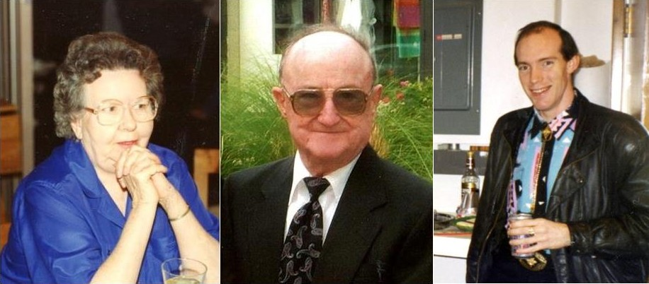
Erwin Heberle was born in Mound City, South Dakota on October 8, 1924. Oldest son of Karl and Adeline Heberle.
Margaret “Bootsie” Manning Heberle was born in Hysham, Montana. Oldest daughter of James and Margaret Manning.
Travis Austin was born in Billings, Montana, the oldest son of Randy Austin and Holly Heberle.
Their lives were forever intertwined, and it is fitting that they are memorialized together.
In 1928, at the age of 4, Erwin moved with his family to Plevna, Montana where they lived until 1939. They then moved to Custer, Montana, where his dad Karl Sr., purchased a service station and repair shop. While Erwin was in high school, he worked very hard alongside his dad while attending school 2 days a week. He was very proud of the fact that he still graduated on schedule in 1942.
Erwin enlisted in the army in April of 1943 and was stationed in Casablanca, Africa until he received an honorable medical discharge. He met Bootsie soon after he returned from service, and they married on March 1, 1952. This began a union that would last the remainder of their lives. Erwin and Bootsie lived in Custer for the first 8 years, during which time they were blessed with 3 daughters; Holly, Nicki and Andrea.
In August of 1960, the family purchased the Tepee Motor Ford dealership in Forsyth, Montana. Erwin and his younger brother Karl, along with their families, were sent to Forsyth to run the dealership. While living in Forsyth, Erwin and Bootsie were blessed with the birth of their 4th daughter, Kristin. This was a very difficult time for the whole family, as Bootsie was hospitalized for a very long period due to complications from childbirth.
In August of 1965 Erwin left the family business and purchased the Ford dealership in Baker, Montana. The business was known as “Erwin Heberle Ford”. Although they experienced much joy during their lives, they both suffered greatly when their beautiful (youngest) daughter Kristin passed away from Leukemia on October 1, 1970.
In July of 1971, Erwin moved his family to Miles City, Montana, where he worked for Love Motor (which later became Miles City Ford). Erwin worked a total of 16½ years at Miles City Ford as general manager. They were blessed once again with the birth of their first grandchild, Travis Alan Austin in November of 1972. He brought joy into their lives, and the three of them were inseparable. Travis was well known and loved by all who met him. Travis was gregarious and outgoing and never knew a stranger. He believed that strangers were simply friends that he had not met yet. His life was not without pain and suffering, as he was diagnosed with juvenile diabetes at the age of 10, which was the cause of his early passing at the age of 40. Travis’ half sister Carma said it best when she learned of his death; “A fond farewell to my half-brother Travis, who did not know adversity in his own mind, despite many hardships. He just picked up and kept on going, a Montana man through and through. I hope he has found a sky bigger than Montana’s; a place to hang his hat and kick off his boots. The kid could really use a break.”
May all three of them rest together in peace and happiness, we love you and we’ll miss you!

Funeral Service
11:00 a.m.
Friday September 19, 2014
Stevenson and Sons Funeral Home
Forsyth, MT 593247

